UNIVERSITY OF WAH (UOW)

DEPARTMENT OF COMPUTER SCIENCE



COURSE TITLE: INTRO TO INFORMATION SECURITY

COURSE CODE: CS – 251 L

SUBMITTED TO: MS. WASIFA KANWAL

SUBMITTED BY: SAADI SAFDAR

REG #: UW-24-CS-BS-088

BSCS 3RD B

LAB ASSIGNMENT # 5

Assigned task in lab.

def playfair_prepare_key(keyword):
"""
Prepares 5x5 Playfair matrix from a keyword.
Merges I/J into a single letter.
"""
alphabet = "ABCDEFGHIKLMNOPQRSTUVWXYZ" # I/J merged
key = ""
# Add unique letters from keyword
for ch in keyword.upper():
if ch not in key and ch in alphabet:
key += ch
# Add remaining letters
for ch in alphabet:
if ch not in key:
key += ch

# Create 5x5 matrix
matrix = []
for i in range(0, 25, 5):
row = key[i:i+5] # Take 5 letters slice for this row
matrix.append(row)
return matrix

def find_position(matrix, letter):
"""Finds row and column of a letter in the matrix"""
for i, row in enumerate(matrix):
if letter in row:
return i, row.index(letter)
return None

def preprocess_text(text):
"""
Prepares text for Playfair cipher:
- Uppercase, replace J with I
- Split into digraphs
- Insert X between repeated letters
- Append X if length is odd
"""
text = text.upper().replace("J", "I")
digraphs = []
i = 0
while i < len(text):
a = text[i]
b = ''
if i+1 < len(text):
b = text[i+1]
if a == b or b == '':
b = 'X'
i += 1
else:
i += 2
digraphs.append(a+b)
return digraphs
def playfair_encrypt(plaintext, matrix):
ciphertext = ""
digraphs = preprocess_text(plaintext)
for pair in digraphs:
r1, c1 = find_position(matrix, pair[0])
r2, c2 = find_position(matrix, pair[1])
# Rule 1: Same row
if r1 == r2:
ciphertext += matrix[r1][(c1+1)%5] + matrix[r2][(c2+1)%5]
# Rule 2: Same column
elif c1 == c2:
ciphertext += matrix[(r1+1)%5][c1] + matrix[(r2+1)%5][c2]
# Rule 3: Rectangle
else:
ciphertext += matrix[r1][c2] + matrix[r2][c1]
return ciphertext

def playfair_decrypt(ciphertext, matrix):
plaintext = ""
digraphs = []
for i in range(0, len(ciphertext), 2):
pair = ciphertext[i:i+2]
digraphs.append(pair)
for pair in digraphs:
r1, c1 = find_position(matrix, pair[0])
r2, c2 = find_position(matrix, pair[1])
# Rule 1: Same row
if r1 == r2:
plaintext += matrix[r1][(c1-1)%5] + matrix[r2][(c2-1)%5]
# Rule 2: Same column
elif c1 == c2:
plaintext += matrix[(r1-1)%5][c1] + matrix[(r2-1)%5][c2]
# Rule 3: Rectangle
else:
plaintext += matrix[r1][c2] + matrix[r2][c1]
return plaintext

keyword = "HOCKEY"
matrix = playfair_prepare_key(keyword)
print("Playfair Matrix:")
for row in matrix:
print(row)

plaintext = "SECURITYLAB"
ciphertext = playfair_encrypt(plaintext, matrix)
decrypted = playfair_decrypt(ciphertext, matrix)

print("\nPlaintext:", plaintext)
print("Ciphertext:", ciphertext)
print("Decrypted:", decrypted)

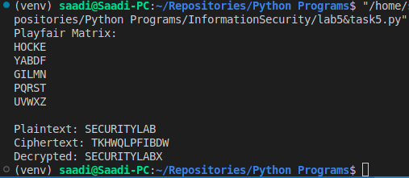

Task 1: Play Fair Cipher :

Dry Run:

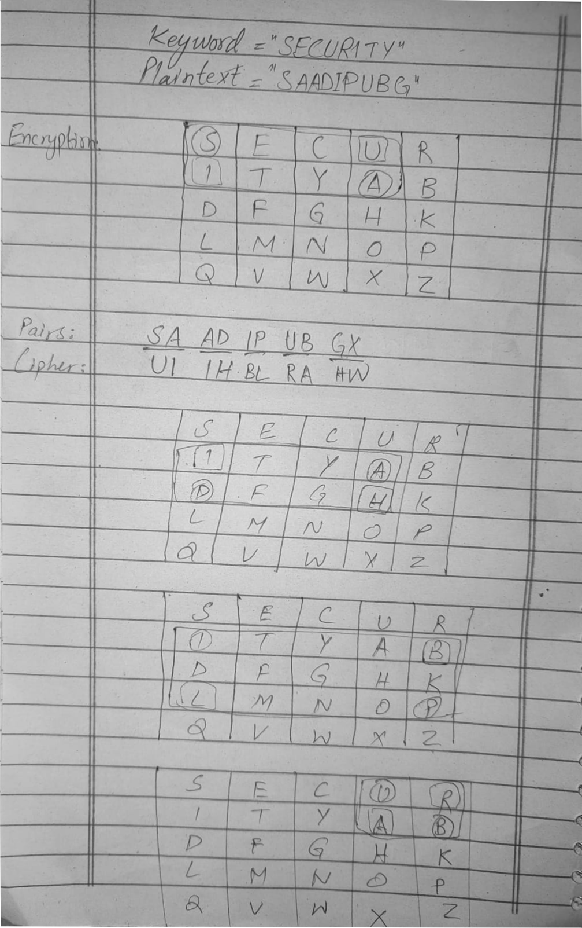

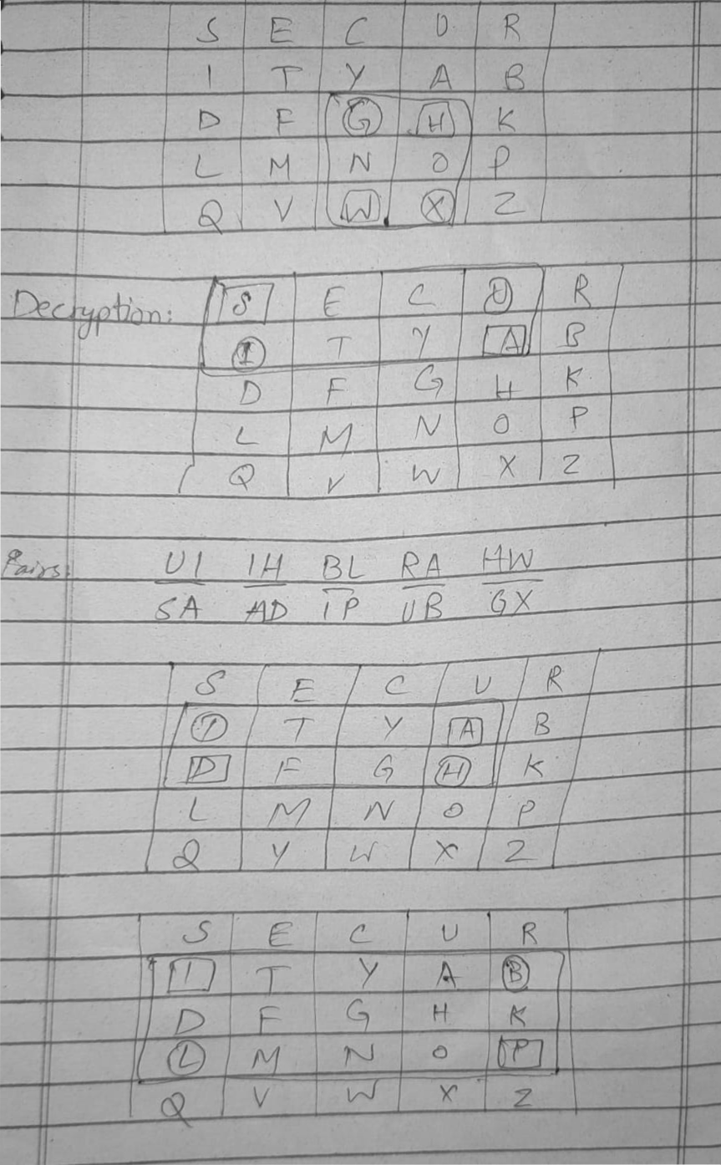

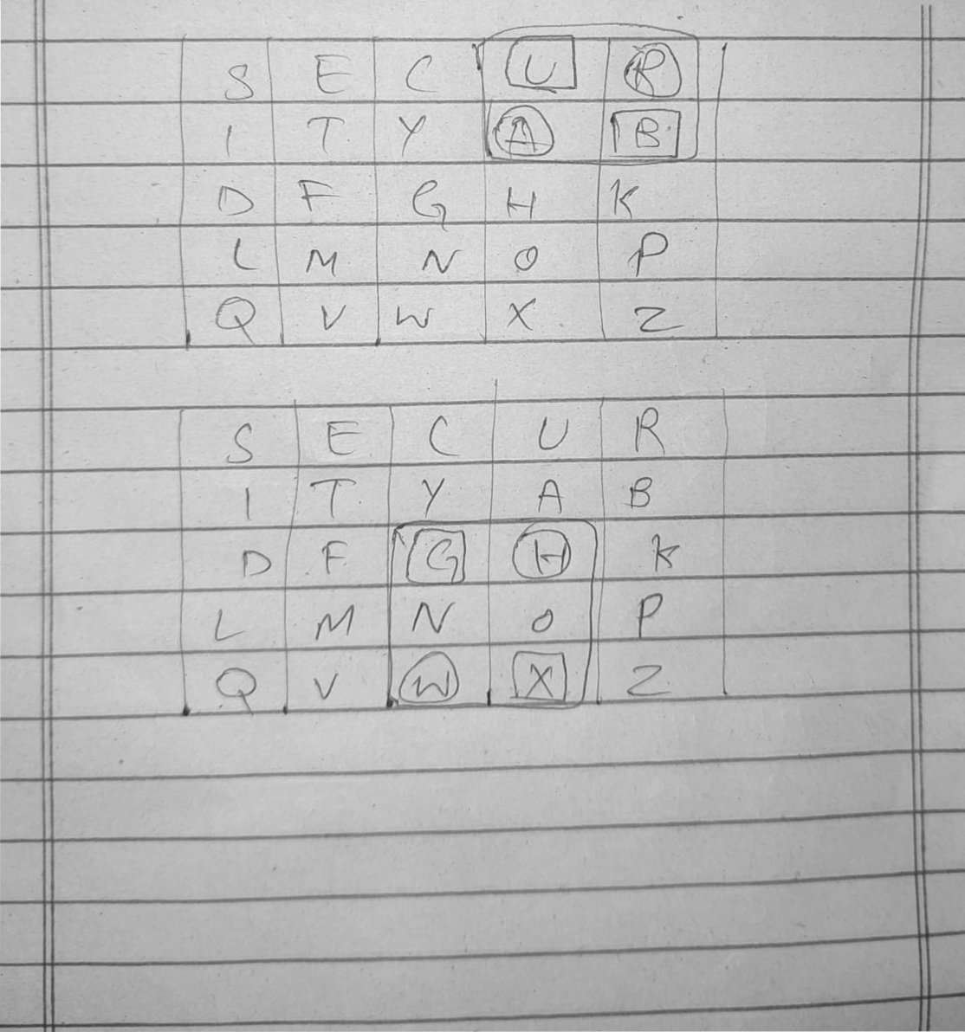

Code:

def playfair_prepare_key(keyword):
"""
Prepares 5x5 Playfair matrix from a keyword.
Merges I/J into a single letter.
"""
alphabet = "ABCDEFGHIKLMNOPQRSTUVWXYZ" # I/J merged
key = ""
# Add unique letters from keyword
for ch in keyword.upper():
if ch not in key and ch in alphabet:
key += ch
# Add remaining letters
for ch in alphabet:
if ch not in key:
key += ch

# Create 5x5 matrix
matrix = []
for i in range(0, 25, 5):
row = key[i:i+5] # Take 5 letters slice for this row
matrix.append(row)
return matrix

def find_position(matrix, letter):
"""Finds row and column of a letter in the matrix"""
for i, row in enumerate(matrix):
if letter in row:
return i, row.index(letter)
return None

def preprocess_text(text):
"""
Prepares text for Playfair cipher:
- Uppercase, replace J with I
- Split into digraphs
- Insert X between repeated letters
- Append X if length is odd
"""
text = text.upper().replace("J", "I")
digraphs = []
i = 0
while i < len(text):
a = text[i]
b = ''
if i+1 < len(text):
b = text[i+1]
if a == b or b == '':
b = 'X'
i += 1
else:
i += 2
digraphs.append(a+b)

return digraphs

def playfair_encrypt(plaintext, matrix):
ciphertext = ""
digraphs = preprocess_text(plaintext)
for pair in digraphs:
r1, c1 = find_position(matrix, pair[0])
r2, c2 = find_position(matrix, pair[1])
# Rule 1: Same row
if r1 == r2:
ciphertext += matrix[r1][(c1+1)%5] + matrix[r2][(c2+1)%5]
# Rule 2: Same column
elif c1 == c2:
ciphertext += matrix[(r1+1)%5][c1] + matrix[(r2+1)%5][c2]
# Rule 3: Rectangle
else:
ciphertext += matrix[r1][c2] + matrix[r2][c1]
return ciphertext

def playfair_decrypt(ciphertext, matrix):
plaintext = ""
digraphs = []
for i in range(0, len(ciphertext), 2):
pair = ciphertext[i:i+2]
digraphs.append(pair)
for pair in digraphs:
r1, c1 = find_position(matrix, pair[0])
r2, c2 = find_position(matrix, pair[1])
# Rule 1: Same row
if r1 == r2:
plaintext += matrix[r1][(c1-1)%5] + matrix[r2][(c2-1)%5]
# Rule 2: Same column
elif c1 == c2:
plaintext += matrix[(r1-1)%5][c1] + matrix[(r2-1)%5][c2]
# Rule 3: Rectangle
else:
plaintext += matrix[r1][c2] + matrix[r2][c1]
return plaintext
keyword = "SECURITY"
matrix = playfair_prepare_key(keyword)
print("Playfair Matrix:")
for row in matrix:
print(row)

plaintext = "SAADIPUBG"
ciphertext = playfair_encrypt(plaintext, matrix)
decrypted = playfair_decrypt(ciphertext, matrix)

print("\nPlaintext:", plaintext)
print("Ciphertext:", ciphertext)
print("Decrypted:", decrypted)

